3,000 lb Capacity Extreme Power for ATV Winch
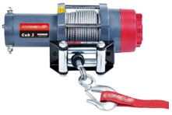
4 Way Roller Fairlead NOT INCLUDED

FEATURES
3,000 lb (1,361 kg) line pull
Power in and power out
Winch drum centred avoids the interference of rope and provides streamlined appearance
Mechanical load holding and dynamic brake for 100% braking
High efficiency, low amp draw and sealed permanent magnet motor
Full metal 3 stage planetary gear train for greater pulling force
Sliding pin and ring gear clutch for rapid wire rope payout
Weather sealed contactor gives better water proof and lower amp. draw
E/e marked as of EU Directive 97/24/EC. EEC Type - Approval Number: e4*97/24*97/24/8/IX*0036*01

SPECIFICATION
- Maximum line pull : 3,000 lb (1,361 kg)
- Motor : Permanent magnet 800w/1.0hp 12V DC motor
- Gear train : 3-stage planetary gears
- Gear ratio : 138.5:1
- Brake : Mechanical & dynamic
- Clutch : Sliding pin and ring gear
- Control : Handlebar rocker switch
- Wire rope : 4.8mm x 15.2m (3/16" x 50'), galvanized aircraft A7 x 19
- Winch construction : Aluminium die cast housings and drum
- Rotation of winch : Wire rope shall be under-wound orientation only
- Drum size : 55mm x 75mm (2.2" x 3")
- Mounting bolts pattern : 76mm x 124mm (3"x 4.9")

LINE PULL AND ROPE CAPACITY
Layer of Wire Rope | Pull by Layer kg / lb | Total Rope m / ft
1st Layer | 1,361 / 3,000 | 2.8 / 9.3
2nd Layer | 1,173 / 2,585 | 6.1 / 20.1
3rd Layer | 1,030 / 2,271 | 9.9 / 32.5
4th Layer | 918 / 2,025 | 14.1 / 46.3
5th Layer | 829 / 1,827 | 15.2 / 50

LINE SPEED AND AMP. DRAW ( 1st layer of rope on the drum)
Line Pull, kg / lb | Line Speed, mpm / fpm | Amp. Draw, A
No Load | 6.8 / 22.2 | 20
227 / 500 | 5.7 / 18.7 | 45
454 / 1,000 | 4.8 / 15.6 | 75
680 / 1,500 | 3.8 / 12.5 | 105
907 / 2,000 | 3.0 / 9.8 | 140
1,134 / 2,500 | 2.5 / 8.0 | 180
1,361 / 3,000 | 2.0 / 6.7 | 230

WARNING
* The winch is not intended to be used in any manner for the movement or lifting of personnel.
* The rated line pull shown is based on the first layer of rope on the drum.
* The rope winding on the drum shall remain 5 wraps from the drum.

DIMENSIONS(mm/in)
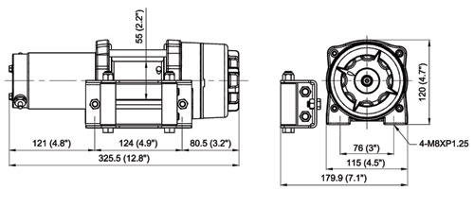

STANDARD ACCESSORIES (included in the package)
- Handlebar rocker switch w/socket wiring
- Wire rope with safety hook
- Colour coded wirings and 6 gauge battery leads
- Base plate

OPTION ACCESSORIES (not included in the package)
- 4 way roller fairlead
- Wireless remote control
- Handheld remote control w/10' (3m) cord
- Snatch block

PACKAGE
- Winch Weight : 8.2 kg / 18 lb (including wire rope)
- Gross Weight : 12.5 kg / 27.6 lb
- Box Dimension : 394 x 331 x 144mm (13.7" x 13" x 5.7")

